1. **Created one IAM user and assigned ec2, s3 full access role.**
2. **Created a role in roles section.**
3. **Attached ec2 and s3 full access**
4. **Attached policy to a role with a name called ec2_s3_access.**
5. **Attached role to the user.**

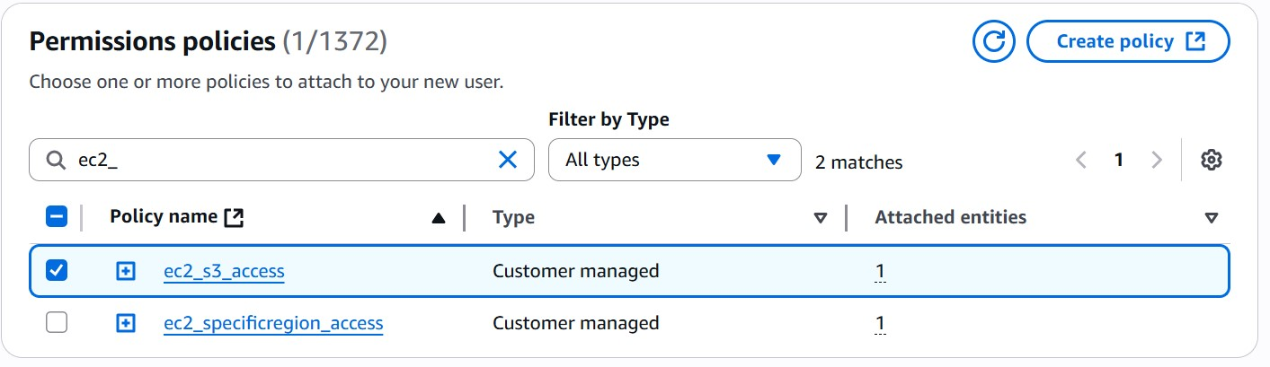

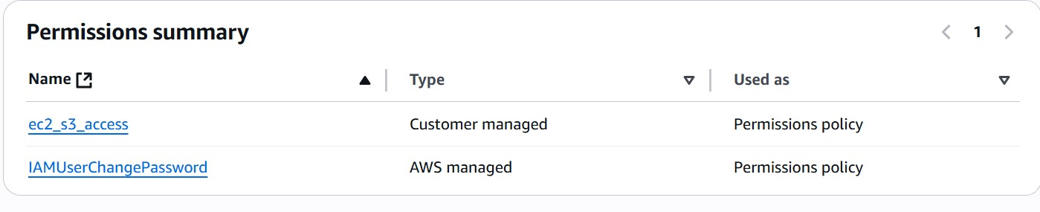

1. **Create one Group in IAM and Assign Read access for ec2.**
2. **IAM -> groups -> created group -> attached policy**

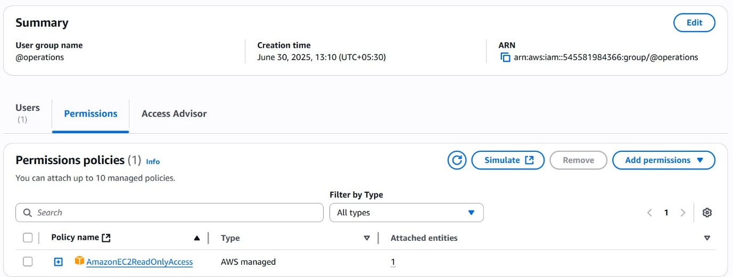

1. **Create a new user with name Devops and add to the group created in task2.**

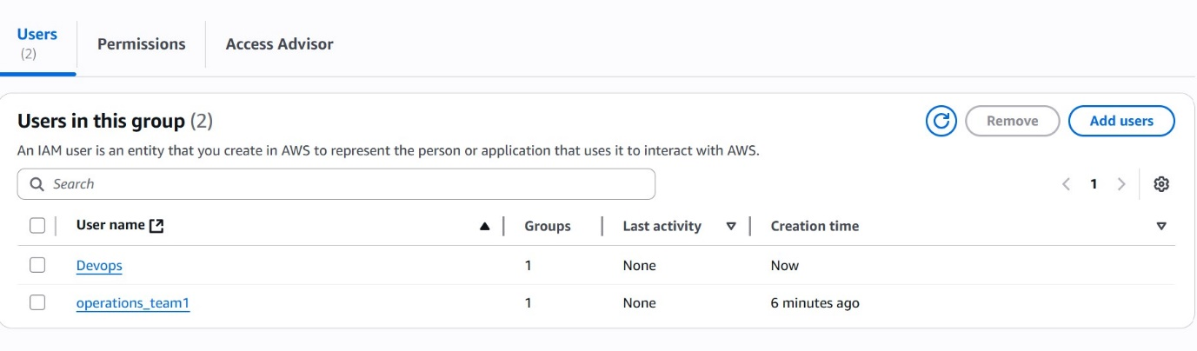

1. **Write a bash script to create a IAM user with VPC full access.**

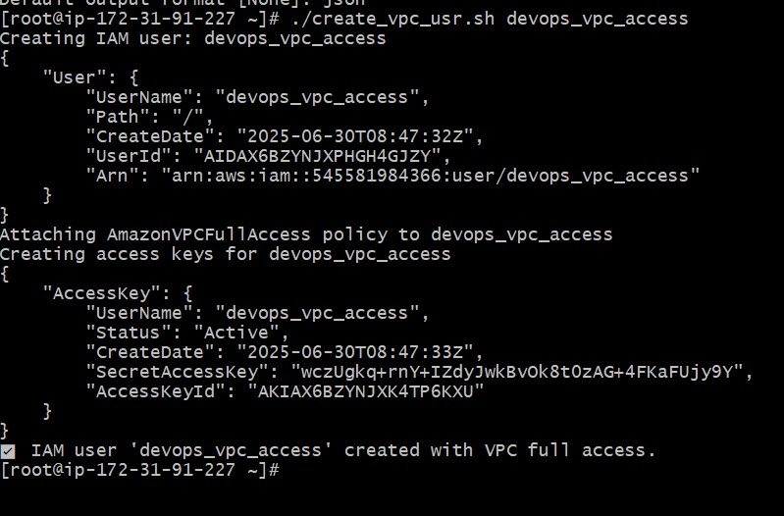

1. **Create a IAM policy to access ec2 for a specific user in specific regions only.**

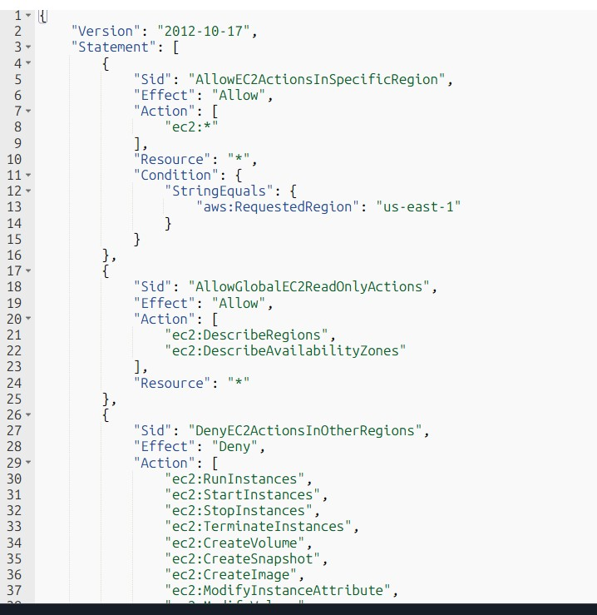

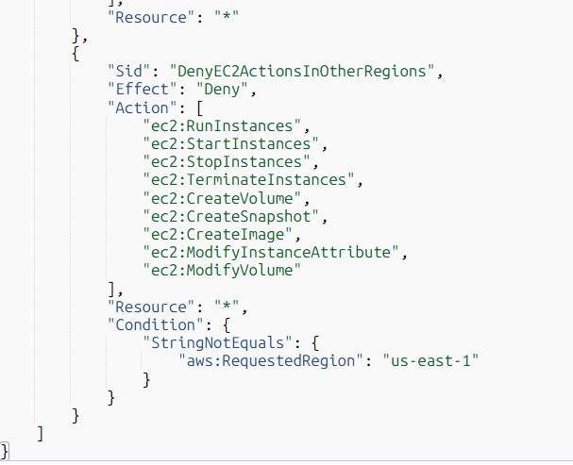

* **Attached policy to the user.**